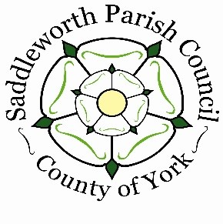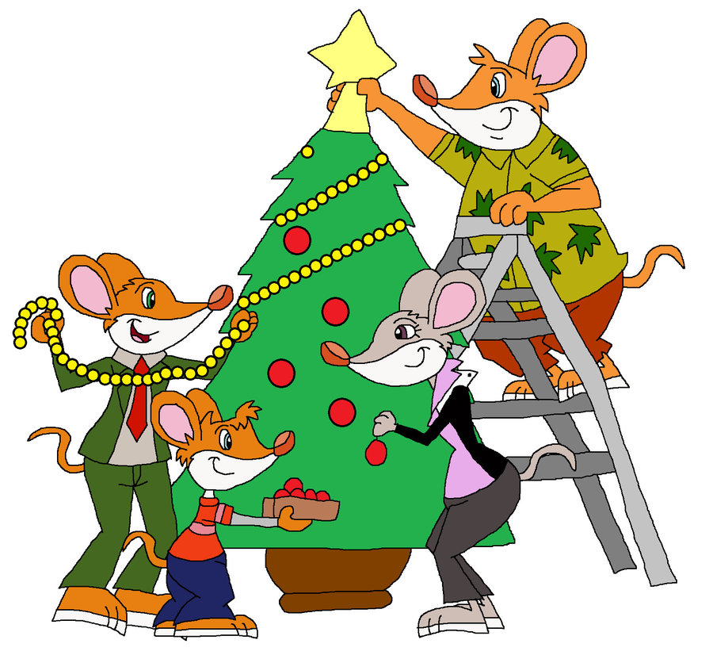

**SADDLEWORTH PARISH COUNCIL**

**CHRISTMAS LIGHTS COMPETITION 2023**

**2023**

**Christmas Lights Competition 2019**

**Categories**

**Best Shop Window, Best Public House,**

**Best Residential Premises and**

**Best Community**

**If you wish to enter this year’s competition**

**Please ring Karen or Hazel 01457 876665 or**

**E-Mail: enquiries@saddleworthparishcouncil.org.uk**

**Judging**

**Week Commencing 11th December 2023**