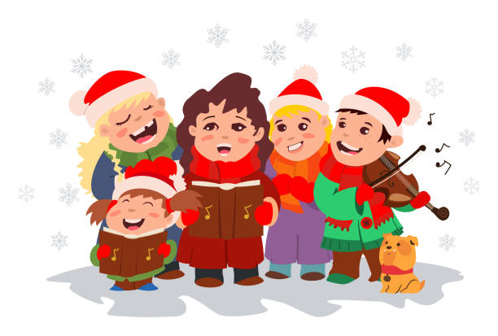

**COMMUNITY CHRISTMAS CAROLS**

**WITH**

**SADDLEWORTH SCHOOL BAND**

**Thursday 21st December 2023**

**10.30am to 12noon**

**LOWER HALL**

**CIVIC HALL, LEE STREET UPPERMILL OL3 6AE**

**Coffee and Mince Pies**

**All Welcome**