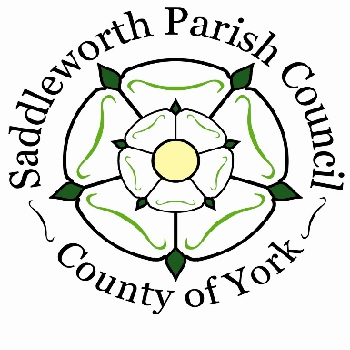

**SADDLEWORTH PARISH COUNCIL**

**CELEBRATING 50 YEARS**

**Of WORKING FOR SADDLEWORTH**

**1974—2024**

Come along and help **us** celebrate

at our Yorkshire Day Anniversary

**Cheese & Wine Event**

The Civic Hall, Uppermill

Sunday 4th August 2024 fro**m** 3pm

