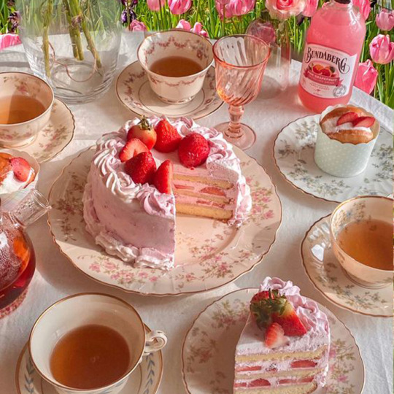

**Saddleworth Parish Council**

**Chairman’s Charity Appeal**

**STRAWBERRY TEA TUESDAY 15th July 2025**

**2pm - 4pm**

**Civic Hall, Uppermill (Lower Hall)**

**Admission £2.50 or free with any Raffle or Tombola Prize**

**Prize**