CHRISTMAS ILLUMINATIONS COMPETITION 2025
SADDLEWORTH
PARISH COUNCIL
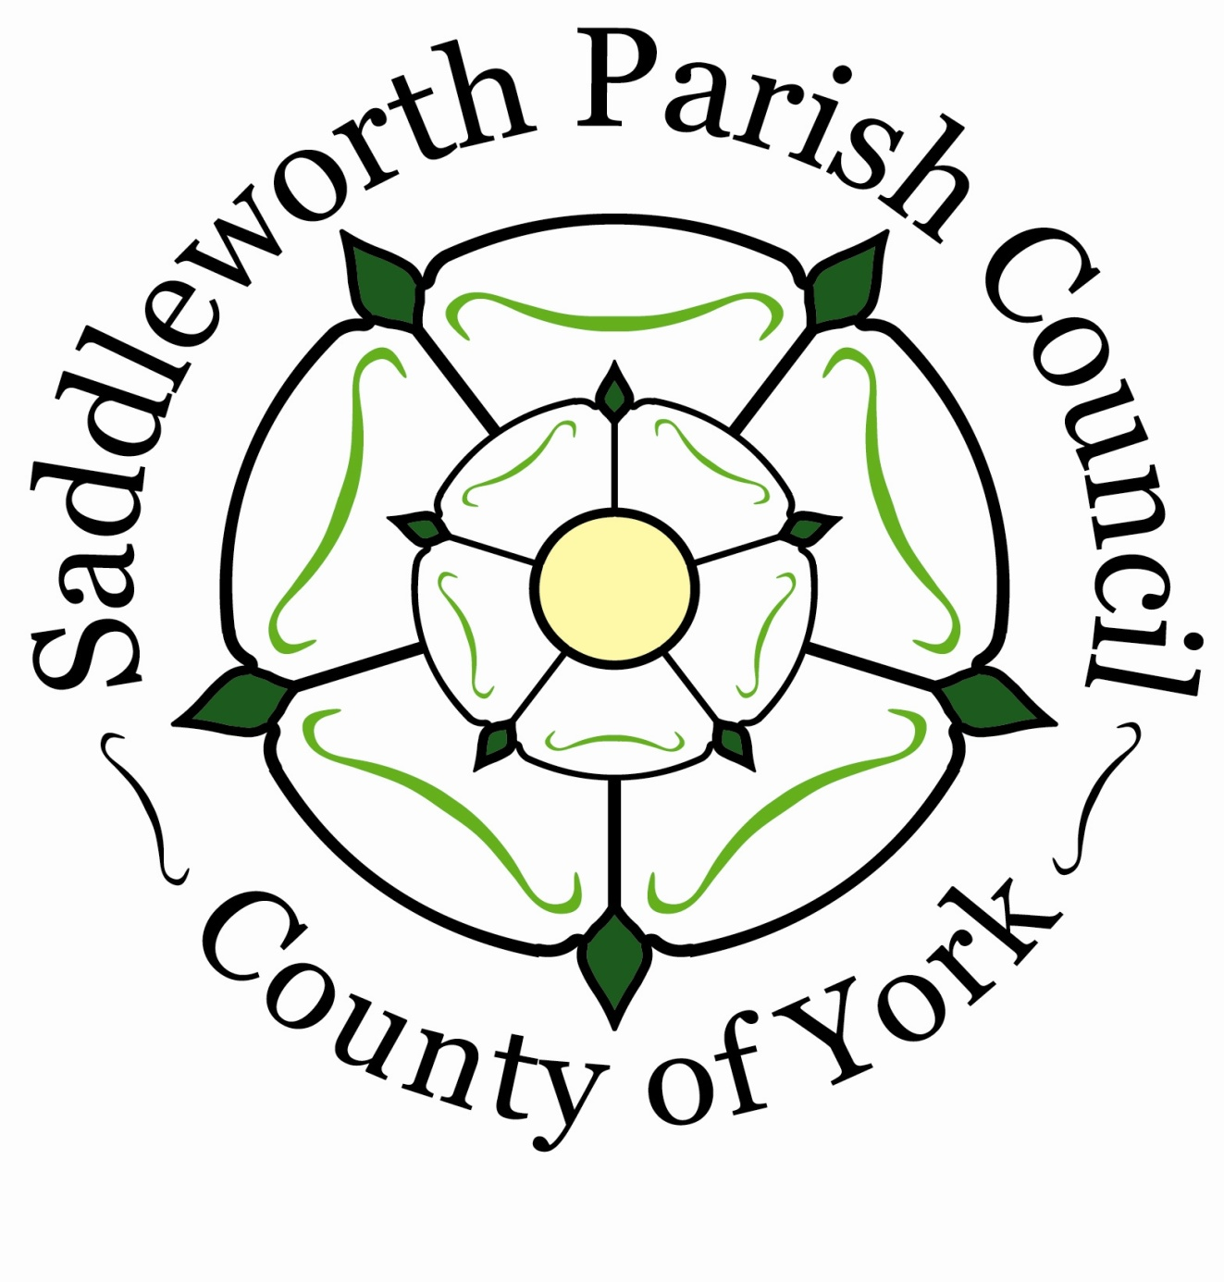

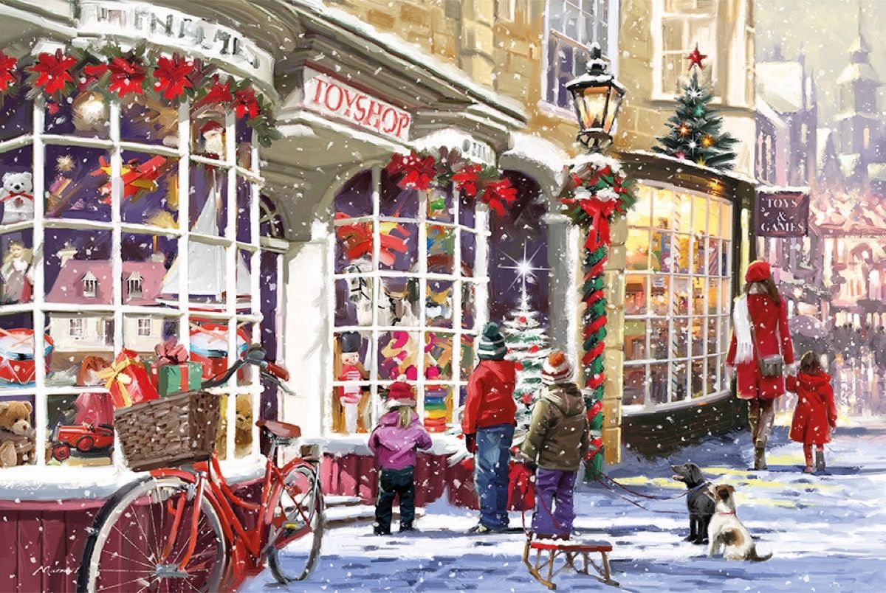

CATEGORIES
Best Illuminated shop window
Best illuminated residential property
Best illuminated pub
Best illuminated community project
Judging will take place on
TUESDAY 16th december 2025 FROM 5.30PM
To enter….
Telephone 01457 876665 or
E-mail : hazel@saddleworthparishcouncil.org.uk

